COWCH notes/changes:

Change the background the white or light peach colour
Remove the heart emoji and yellow circle around cow logo
Move explore IMAGINE above Moove to the cowch

I – Me, Myself and I
Wellness check in:
Rate your mood out of 10, 1 being very low in mood and 10 being very contented.
If your score is lower than a 6, ask yourself what you could do to raise it one point
You could go for a walk; listen to happy music, call a friend, play with a pet, think about something that makes you smile or that you are looking forward to.
Rate your exercise levels out of 10, in terms of how happy you are with your current exercise routine 1 2 3 4 5 6 7 8 9 10
Rate your diet satisfaction- how happy are you with your eating habits and the food you are eating? 1 2 3 4 5 6 7 8 9 10
Rate your satisfaction in terms of appearance out of 10. Examples – do you take care of your appearance, hygiene, physical and mental health.
Rating the above areas will help you identify what needs more work or focus:
Write down suggestions here for what you could do to improve certain areas:
Example: Go to the gym twice instead of once per week; make sure to eat salad at least once per week; book a massage
Boundary setting
Think about people who have overstepped the mark. Have you allowed them to ignore your boundaries? When we have healthy boundaries, we improve our self-confidence and our relationships.
Be brave and say “No”. You don’t need to always make others happy; your self-care comes first… always.
Energy Audit
Underneath the current content:

List the things that bring you positive energy:

List the things that bring negative energy and drain you

Try to keep balance with more positive energy coming into your life.
Examples of positives: good friends, mentors, sleep, fun, watching comedies, music, etc
Examples of negatives: toxic people, a job that you hate, lack of sleep, being passive when assertiveness is required etc

Mindfulness:
Sensational vacation:
5 things you can see – Put an explanation underneath:
“When you are using your 5 senses your brain doesn’t have time to engage with your worries. It’s a great mental break for your mind and body”
Body scan:
Progressive muscle relaxation (PMR) is a wonderful way to relax the body and to become more of aware of tension. When we are tense, we send involuntarily send a message to our brains that we feel in danger. When the amygdala (the body’s alarm system) suspects danger, it puts the body on full alert – pushing us into fight, flight, freeze, faun or feint mode.
PMR helps us feel calm and turn off the amygdala. It’s exhausting for the body to be in threat mode indefinitely.
Progressive Muscle Relaxation helps reduce stress by tensing and then relaxing muscle groups one by one.
- Sit or lie down comfortably.
- Start with your feet: tense the muscles for 5 seconds, then release and notice the relaxation.
- Move upward—legs, stomach, hands, arms, shoulders, face—tense, then relax each group.
- Breathe slowly and notice the difference between tension and calm.
In just a few minutes, your body feels looser and your mind calmer.
Added tip: It’s also perfect for when you want to sleep better and can be done before bedtime.

Acceptance
Take a slow breath and tell yourself: ‘This is the reality right now.’ Remember, acceptance isn’t approval — it’s letting go of extra suffering.

Cow-dance
Resisting what you cannot change creates more suffering. Think of situations that you resist instead of accepting. What would accepting this situation allow you to feel/do?
Thought unhooking
Learn to detach from anxious thoughts by thinking of them as leaves floating by on a stream. You can let them pass, you don’t need to pick up every leaf (thought) and focus on it. Did you know that:
Humans have about 6,000 distinct thoughts a day (based on the best current study).
Most are repetitive or fleeting; only a fraction are directly useful for goals, problem-solving, or well-being.
Thoughts aren’t facts!!
What thought is bothering you right now?
Write the thought….
Now reframe the thought, challenge negative thoughts regularly:
Original thought example: Once people really get to know me, they won’t like me
Reframe: No one is perfect and not everyone I know dislikes me.
Don’t believe every thought you think. Most of our negative thoughts are based on fear and insecurity, not on the truth.
Self-compassion practice:
Self-compassion helps calm both mind and body. When we treat ourselves with kindness instead of harsh self-criticism, our nervous system shifts into a soothing state that lowers stress and tension. MRI studies show that self-criticism activates the brain’s threat system, flooding us with stress responses, while self-compassion activates areas linked with safety and care. In short, being gentle with yourself is not indulgent — it’s a proven way to reduce stress and support mental health.
Treat yourself with kindness using H-E-A-L: It helps you manage negative thinking whilst being kind to yourself.
H = helpful. Is the negative thought helpful… usually the answer is NO. Asking whether a thought is helpful can quickly bring to your awareness that this is a thought to let go of and not focus on. What we focus on become our reality and determines our quality of life.
E = evidence. Where is the evidence for/against the thought? You will find most negative thoughts have very little ACTUAL evidence (the type that would stand up in a court of law).
Example: You come into the office and say “hello” to a colleague and they ignore you. Often, we rush to judgement and think we have done something wrong (this is an error in thinking known as Personalising).
Ask yourself where is the evidence that you have done something wrong. There probably won’t be any evidence because you are making assumptions (another error in thinking called ‘Mind reading’).
A = Alternative. This is reframing (discussed in the previous section). Ask yourself what you can tell yourself about the situation that will make you feel better.
Example: No, my colleague isn’t annoyed at me as I haven’t done anything. Perhaps they are just having a bad day.
L = Loved one
This is where self-compassion comes in. What would you say to a loved one who told you their colleague was mad at them? It’s unlikely you would tell them they must have done something wrong or that they are loser. You would be supportive and encouraging and this exactly the way you should talk to yourself.

Self-compassion calms your body and mind, while self-criticism triggers the brain’s threat system.

Radical Acceptance
Ask yourself: What am I resisting?
Example: Your relationship is over but you keep hoping to get your ex back when they have not shown any interest. When we engage in self-pity or the “Why me?” dialogue, we prolong our suffering.
Radical Acceptance Exercise 1
- Notice the struggle: Bring to mind a situation that feels unfair, painful, or out of your control.
- Name the reality: Silently say to yourself, “This is what’s happening right now.”
- Drop the fight: Instead of pushing the situation away with “it shouldn’t be this way,” try softening into acceptance: “I may not like it, but this is the reality I face.”
- Breathe into it: Take a slow breath, and imagine your breath making space around the pain.
- Shift toward peace: Remind yourself: “Accepting reality doesn’t mean approving of it — it means freeing myself from extra suffering.”
Radical Acceptance Exercise 2
Acceptance Reaffirmation Exercise
- Settle and breathe: Sit comfortably, close your eyes, and take a few slow breaths.
- Recall a struggle: Think of something recent that you’ve been resisting or holding onto.
- Whisper acceptance: Silently say, “I don’t have to fight this right now. I can let go.”
- Reaffirm the benefits: With each breath, repeat gentle reminders:
  - “Acceptance helps me move forward.”
  - “Letting go brings me peace.”
  - “When I accept, I feel lighter, calmer, and more centred.”
  - “Letting go of what I can’t control will help me feel more content.”
- Rest in calm: Place your hand on your heart, notice the warmth, and sit quietly for a moment, allowing the sense of relief/peace to sink in.
Result: A calmer body, a quieter mind, and a gentle reminder that acceptance is the path to progress and peace.
Let go of what you can’t control – all we really have control over is our thoughts and behaviours. Your power lies within.

Gratitude
Small wins
Celebrate minor victories exercise:
Gratitude for Small Wins
- Pause and reflect: Think back over today (or yesterday) and notice one small win — it could be finishing a task, getting out of bed when it felt hard, sending that message, or even just taking a breath to calm yourself.
- Acknowledge it: Say to yourself, “That mattered. I did that.”
- Feel the gratitude: Place your hand on your chest and take a slow breath, letting yourself feel thankful for the effort you made, no matter how small.
- Lock it in: Smile gently and whisper, “Small steps lead to big changes.”
Practicing gratitude for little wins builds confidence, motivation, and a sense of progress.

Create a gratitude journal to read when you need a boost:
Write it down: (this section is an easy to access journal to write down happy things… )

Soothing one liners to rotate as pop-ups in app:

“Every small step counts — take a moment to thank yourself for it.”
“Celebrate the little wins; they’re the building blocks of big change.”
“Gratitude grows when you notice the small things you’ve achieved today.”
“Even the tiniest progress is proof you’re moving forward.”
“Pause, smile, and give thanks for what you managed today — it matters.”
“Small wins = quiet victories. Be grateful for each one.”

30-60 second daily gratitude exercise (repetition is key)

Daily Gratitude for Small Wins
- Pause: Close your eyes and take one slow breath in, one slow breath out.
- Recall: Think of one small win from today (or yesterday) — something you did, no matter how simple.
- Acknowledge: Say to yourself, “That mattered. I did that.”
- Feel: Place your hand on your heart and notice the warmth. Let gratitude for that moment settle in your body.
- Finish: Smile gently and whisper, “Small wins move me forward.”
Time: Less than a minute. Effect: A calm, grounded sense of progress and self-appreciation.

GUIDED AUDIO SCRIPT???? Could this be added with me narrating?

Guided Audio Script: Gratitude for Small Wins
(soft, calm tone)
“Find a comfortable position… gently close your eyes if that feels okay… and take a slow, deep breath in… and let it out…
Now, bring to mind one small win from today… or yesterday. It doesn’t need to be big. Maybe you got out of bed when it felt difficult… finished a task… took a moment to rest… or simply remembered to breathe.
Whatever it is, let yourself see it clearly. Hold that moment gently in your mind.
Now say to yourself, ‘That mattered. I did that.’
Place your hand softly over your heart… and notice the warmth beneath your hand. With each breath, let a feeling of gratitude spread through your body. Gratitude for your effort… gratitude for showing up in your own way today.
Take one more deep breath in… and slowly release it.
As you come back to the present moment, whisper to yourself: ‘Small wins move me forward.’
When you’re ready, open your eyes. Carry this gentle gratitude with you.”

Interactions

Connection web:

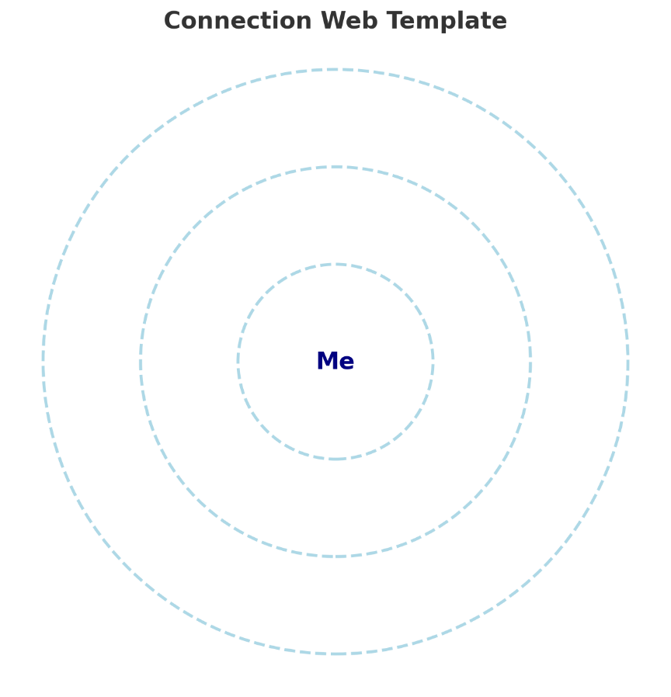

Add interactive nodes (supportive, neutral, draining) into the different rings dynamically
as users build their web.
Example:
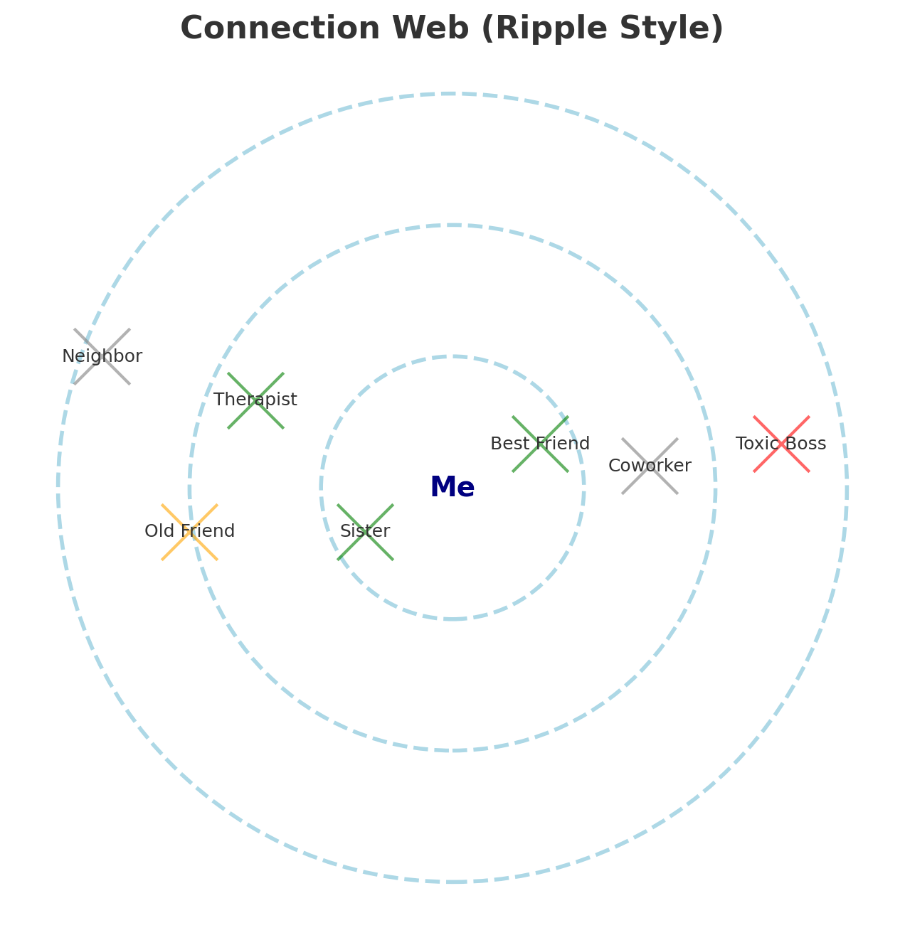
1. Visual Layout
- Concentric circles (like ripples in water):
  - Center = the user (“Me”).
  - Inner circle = closest, most supportive relationships.
  - Middle circle = moderate or situational connections (friends, coworkers).
  - Outer circle = distant or draining connections.
This gives a clear visual of closeness and emotional impact.

2. Adding Connections
- Tap “+ Add Connection”.
- User enters:
  - Name (or nickname, e.g. “Best friend,” “Sister”).
  - Type (Family, Friend, Partner, Work, Professional, Other).
  - Emotional impact: Supportive / Neutral / Draining (with simple icons like ☀️, ⚪, ⚡).
- The connection appears as a node (circle) in the chosen ring.

3. Interactivity
- Drag & Drop: Move connections closer or further from the center as relationships change.
- Color coding: Supportive (green/blue), Neutral (grey), Draining (red/orange).
- Tap a node: Pop-up options:
  - Add a note (e.g., “I feel calmer after talking to them”).
  - Quick action (e.g., “Reach out,” “Set boundary,” “Express gratitude”).

4. Reflection Prompts
After creating or editing the web, users see supportive questions:
- “Who in your inner circle lifts you up the most?”
- “Is there someone draining you who might need a boundary?”
- “Is there a connection you’d like to strengthen?”
This helps the web become more than a map — it’s a self-reflection tool.

5. Progress Tracking
- Option to save versions of the web over time.
- Users can revisit and notice shifts: “Wow, I moved this person closer to the center” or “I’ve let go of that draining connection.”

6. Soothing Element
Because this is a mental health app, the web should feel gentle, not clinical:
- Use soft colours, rounded edges.
- Add a calming animation (like the circles pulsing slowly, like a breath).
- Offer reassuring text after changes:
  - “Every relationship teaches you something.”
  - “It’s okay to protect your peace.”

Outcome: The Connection Web becomes a visual diary of the user’s social world, a tool for building gratitude for supportive ties, and a gentle prompt to set boundaries where needed.

General Interaction Exercises (for all users)
These focus on deepening bonds, building consistency, and appreciating existing connections.
- Daily Connection Check-In
  - Prompt: “Send a kind message to one person today — it could be as simple as ‘thinking of you.’”
  - Benefit: Builds consistency in reaching out, strengthens bonds.
- Active Listening Mini-Practice
  - During your next conversation, practice: Listen fully, pause before replying, reflect back one thing they said.
  - Benefit: Improves quality of conversations, fosters empathy.
- Gratitude in Relationships
  - Exercise: Write down one thing you appreciate about a friend, family member, or partner. Option to share it with them.
  - Benefit: Increases warmth and reciprocity.
- Connection Goals
  - Weekly prompt: “Who would you like to connect with this week? Schedule one interaction.”
  - Benefit: Encourages proactive social planning.
- Kindness Ripple
  - Task: Perform one small act of kindness for someone (holding a door, compliment, sharing a smile).
  - Benefit: Boosts mood, increases social approach behaviors.

Interaction Exercises for Users with Social Anxiety
Here the focus is on gentle exposure, self-compassion, and small achievable steps.
- Comfort Zone Ladder
  - Users create a small ladder of social challenges: e.g., Step 1: make eye contact, Step 2: smile at someone, Step 3: say hello, Step 4: ask a small question.
  - The app guides them to practice one step at a time.
- Breathing Before Social Situations
  - Quick guided breath exercise: “Breathe in for 4, hold for 2, breathe out for 6.”
  - Prepares body to feel calmer before interactions.
- Reframing Social Thoughts
  - Prompt: “What’s one anxious thought before talking to someone? Now write a kinder, more balanced version.”
  - Example: “They’ll think I’m awkward” → “They’re just another human, likely glad I said hi.”
  - One in four people globally live with an anxiety disorder, so I am not alone.”
- Self-Compassion Break After Interaction
  - Post-conversation reflection: “No matter how it went, I showed courage by engaging.”
  - Soothes harsh self-criticism.
- Celebrate Small Social Wins
  - Each time a user completes a social step, the app encourages: “Well done — even the smallest interaction is progress.”

General Interaction Program (1 Week)
For users who want to deepen bonds and connect more often.
Day 1 – Daily Check-In
- Send a short, kind message to one person (e.g., “thinking of you,” “hope you’re doing well”).
Day 2 – Active Listening Practice
- In your next conversation, pause before replying and reflect back one thing the person said.
Day 3 – Gratitude Note
- Write down one thing you appreciate about someone. If you feel comfortable, share it with them.
Day 4 – Small Act of Kindness
- Do something small for someone: hold a door, compliment, or share a smile.
Day 5 – Connection Goal
- Choose one person you’d like to connect with this week and schedule a chat, call, or coffee.
Day 6 – Celebrate Support
- List three people who support you in some way. Reflect for a moment on how they help you.
Day 7 – Reflect & Reset
- Ask yourself: Which connection felt strongest this week? Note one small way you can nurture it next week.

Difficult conversations

When facing a tough conversation, try using an assertive script: start with “I feel…” to describe your emotions, explain the specific behavior that affects you, and finish with what you’d like instead. For example: “I feel frustrated when meetings start late because it throws off my schedule. I’d appreciate if we could start on time.” This keeps the focus on your experience rather than blaming. Avoid phrases like “You always” or “You never”, which can make others defensive. Instead, stick to concrete examples, speak calmly, and listen as well as share — this creates space for real understanding.
Assertive Script Template
- State your feeling
  - “I feel _________” (e.g., “I feel upset,” “I feel overlooked”).
- Describe the specific behavior
  - “…when _________” (e.g., “…when my messages aren’t answered,” “…when meetings run late”).
- Explain why it matters
  - “…because _________” (e.g., “…because it makes me feel unimportant,” “…because it throws off my schedule”).
- Make a clear request
  - “I would appreciate it if _________” (e.g., “…if you could reply when you have time,” “…if we could start meetings on time”).

Example:
“I feel stressed when I’m interrupted, because I lose my train of thought. I’d appreciate it if I could finish my point before you respond.”

Nurturing – fun/playfulness
Fun Prompt Generator
Each day, the app can pop up one playful suggestion — something small, easy, and uplifting.
Example Prompts
- Do a silly dance for 30 seconds.
- Tell yourself the worst (cheesiest) joke you can think of.
- Put a random object on your head and see how long it balances.
- Hum your favorite song out loud like nobody’s listening.
- Try speaking in a silly accent for a minute.
- Draw a doodle with your non-dominant hand.
- Pretend you’re a kid again — skip, hop, or spin in a circle.
- Find one tiny thing that makes you smile right now.
How it works in-app
- Daily Spin: Users tap “Get My Fun Prompt” → a random playful activity appears.
- Log It: After trying it, they can note: “Did I do it?” and “How did it feel?”
- Streaks/Rewards: Completing prompts can unlock playful badges (e.g., “Silly Streak,” “Dance Break Hero”).

Fun & Playfulness Diary
Check-in a few times per week to be aware of how much fun/playfulness you nurture/include in your life
Why it matters: Fun and play aren’t just for children — they lift mood, reduce stress, and remind us not to take life too seriously. Even a few minutes of play can shift your energy.
Daily Log
- Today I had fun when… _____________________
- Something playful I tried today was… _____________________
- How it made me feel: 😊 😌 😂 🎶 (pick an emoji or write a word)
Ideas for Playfulness
- Be silly on purpose — make a funny face in the mirror.
- Put on a favourite song and dance around the room.
- Tell a joke (or look up a cheesy one).
- Try a playful challenge, like balancing something on your head.
- Remind yourself: “It’s okay to laugh at myself and not take life too seriously.”
- Watch a funny movie
- Try a mud bath… just for fun… and a good shower afterwards!

If silliness isn’t really your thing, here are other suggestions:

Calming Playful Prompts
- Light a candle and watch the flame dance for a minute.
- Gently sway side to side with your eyes closed, like a tree in the breeze.
- Pick a random word and see how many rhymes you can come up with.
- Close your eyes and imagine your favorite cozy place in detail.
- Make up a tiny story about an object near you (e.g., “This mug secretly dreams of being a superhero”).
- Trace a smiley face with your finger on the palm of your hand.
- Listen to a song and tap along softly, like your fingers are tiny drumsticks.
- Look for something shaped like a heart in your surroundings.

Creative expression

Choose a hobby or something you love to do – flying a drone, painting, drawing, pottery… whatever takes your fancy and schedule in time each month. Even better if you are learning a new skill.
Record your creative expression here:

Creativity log:

Date/ creative activity/ rate it on: achievement (1-10), enjoyment (1-10), closeness (1-10) if you are doing the activity with others.

Inner Child:
Inner Child Play Exercise
- Pause & Remember: Close your eyes and think of something you loved doing as a child — maybe colouring, blowing bubbles, colouring- in, skipping, eating messily with your fingers or building little forts.
- Choose One: Pick a simple version you can do right now (or later today).
- Play for 5 minutes: Do it with no pressure, no goal, and no judgment — just for fun.
- Notice the Feeling: Ask yourself, “How does my inner child feel right now?” and enjoy any sense of freedom, silliness, or calm.

🌈 Inner Child Prompts
- Doodle or colour something without worrying how it looks.
- Blow bubbles (or imagine doing it if you don’t have any).
- Put on your favourite childhood song and dance like you did back then.
- Build a tiny “pillow fort” or cozy corner and sit inside for a few minutes.
- Eat a snack you loved as a kid — mindfully, enjoying each bite.
- Skip, hop, or spin in a circle just for fun.
- Watch a short cartoon or funny video you enjoyed growing up.
- Play with textures: squish playdough, clay, or just roll a pen around in your hands.
- Pretend you’re a superhero and strike your best “power pose.”
- Think of your younger self and whisper: “You’re safe, and you can play.”
✨ Inner Child Reflection Prompt
After your playful moment, take a pause and ask yourself:
- “How did I feel while doing this?”
  - Calm 🌿
  - Joyful 😄
  - Nostalgic 💭
  - Silly 🎈
  - Free 🌈
  - Other: __________
Then complete this thought:
- “Connecting with my inner child reminded me that…” __________________

Explore
Values compass

Trigger Mapping

Thought Record

SAFETY BEHAVIOURS – how to gain confidence and maximise your potential

